Saint Thomas Church Fifth Avenue
in the
City of New York

One West Fifty-third Street
New York, New York 10019
Telephone: 212-757-7013
www.SaintThomasChurch.org
The Reverend Canon Carl F. Turner, Rector

Wednesday, November 20, 2024 at 5:30 p.m.
Choral Evensong for the Eve of Thanksgiving Day
Sung by the Saint Thomas Choir of Men and Boys
Recorded for broadcast on BBC Radio 3




ASSISTING CLERGY
Welcome to Saint Thomas Church, a parish of the Episcopal Diocese of New York.
Our mission is to worship, love, and serve Our Lord Jesus Christ
through the Anglican tradition and our unique choral heritage.

contact us: welcome@saintthomaschurch.org

Please do not take photographs or videos, or make recordings during the service.

The Reverend Matthew Moretz
Vicar and Chief Operating Officer
The Reverend Alison J. Turner
Associate for Children & Family Ministry and School Chaplain
The Reverend Mark Schultz
Associate for Pastoral Care
The Reverend Prisca Lee-Pae
Associate for Pan-Asian Ministry
The Reverend Dr. Luigi Gioia
Theologian in Residence
The Reverend Preston Gonzalez-Grissom
Assistant Priest for Children and Family Ministry

STAFF
Dr. Jeremy Filsell, Organist and Director of Music
Nicolas Haigh, Associate Organist
Maks Adach, Associate for Musical Studies and Assistant Organist
Bruce Smith, Chief Advancement Officer
Adam MacDonald, Director of Development
Blake Martin, Director of Communications and Digital Production
Lizette Hernandez, Executive Assistant to the Rector
David Bryan, Head Verger

SAINT THOMAS CHOIR SCHOOL
Christopher Seeley, Head of School
202 West 58th Street, New York, NY 10019
Telephone: 212-247-3311 email: admissions@choirschool.org
www.ChoirSchool.org

HONORARY CLERGY
The Reverend Andrew C. Mead, OBE, DD, Rector Emeritus
The Right Reverend Andrew R. St. John, DD, Bishop in Residence
The Reverend Mark Brown, Honorary Assistant
The Reverend Canon Anne Mallonee, Honorary Assistant
The Reverend Stephen Morris, Honorary Assistant
The Reverend David F. Mc Neeley, Honorary Assistant
The Reverend Thomas F. Pike, Honorary Assistant

THE LAY MEMBERS OF THE VESTRY

Lloyd G. Stanford, Warden
Karen Duncan
Christopher M. Haley, Clerk
Darren Littlejohn
Winnie Kung
Gregory Zaffiro, Warden
Samyel Lee
John G. Oghia
Benita Potters
Inge Reist
Karl C. Saunders, Treasurer

You may contact the Wardens using this address: Wardens@SaintThomasChurch.org.
Prelude Prelude on ‘Materna’ Calvin Hampton (1938-1984)
The People stand at the entry of the Choir and Ministers.

Introit Gerre Hancock (1934-2012)
T
he Lord is in his holy temple: let all the earth keep silence before him.
The Lord preserve thy going out and thy coming in:
from this time forth for evermore. Amen.

Eternal God, thou crownest the year with thy goodness
and thou givest us the fruits of the earth in their season:
grant that we may use them to thy glory,
for the relief of those in need and for our own well-being;
through Jesus Christ our Lord. Amen.

Habakkuk 2:20; Psalm 121:8; Collect for Thanksgiving Day

Versicles and Responses Gerre Hancock

The Officiant and Choir sing the opening responses.

. O Lord, open thou our lips.
. And our mouth shall show forth thy praise.

. O God, make speed to save us.
. O Lord, make haste to help us.

. Glory be to the Father, and to the Son, and to the Holy Ghost.
. As it was in the beginning, is now, and ever shall be, world without end. Amen.

. Praise ye the Lord.
. The Lord’s Name be praised.

The People sit.

Welcome

Psalm 126 Sung by the Choir Anglican Chant (Turle)

in convertendo
W
hen the Lord turned again the captivity of Sion :
then were we like unto them that dream.
Then was our mouth filled with laughter : and our tongue with joy.
Then said they among the heathen : The Lord hath done great things for them.
Yea, the Lord hath done great things for us already : whereof we rejoice.
Turn our captivity, O Lord : as the rivers in the south.
They that sow in tears : shall reap in joy.
He that now goeth on his way weeping, and beareth forth good seed :
shall doubtless come again with joy, and bring his sheaves with him.
Glory be to the Father, and to the Son : and to the Holy Ghost;
as it was in the beginning, is now, and ever shall be : world without end. Amen.
Psalm 127 Anglican Chant (Parratt)

nisi dominus
E
xcept the Lord build the house : their labour is but lost that build it.
Except the Lord keep the city : the watchman waketh but in vain.
It is but lost labour that ye haste to rise up early, and so late take rest,
and eat the bread of carefulness : for so he giveth his beloved sleep.
Lo, children and the fruit of the womb : are an heritage and gift that cometh of the Lord.
Like as the arrows in the hand of the giant : even so are the young children.
Happy is the man that hath his quiver full of them :
they shall not be ashamed when they speak with their enemies in the gate.
Glory be to the Father, and to the Son : and to the Holy Ghost;
as it was in the beginning, is now, and ever shall be : world without end. Amen.

Psalm 128 Anglican Chant (Goss)

beati omnes
B
lessed are all they that fear the Lord : and walk in his ways.
For thou shalt eat the labours of thine hands : O well is thee, and happy shalt thou be.
Thy wife shall be as the fruitful vine : upon the walls of thine house.
Thy children like the olive-branches : round about thy table.
Lo, thus shall the man be blessed : that feareth the Lord.
The Lord from out of Sion shall so bless thee :
that thou shalt see Jerusalem in prosperity all thy life long.
Yea, that thou shalt see thy children's children: and peace upon Israel.
Glory be to the Father, and to the Son : and to the Holy Ghost;
as it was in the beginning, is now, and ever shall be : world without end. Amen.

Psalm 129 Anglican Chant (Wesley)

saepe expugnaverunt
M
any a time have they fought against me from my youth up : may Israel now say.
Yea, many a time have they vexed me from my youth up :
but they have not prevailed against me.
The plowers plowed upon my back : and made long furrows.
But the righteous Lord : hath hewn the snares of the ungodly in pieces.
Let them be confounded and turned backward: as many as have evil will at Sion.
Let them be even as the grass growing upon the house-tops :
which withereth afore it be plucked up;
Whereof the mower filleth not his hand : neither he that bindeth up the sheaves his bosom.
So that they who go by say not so much as, The Lord prosper you :
we wish you good luck in the Name of the Lord.
Glory be to the Father, and to the Son : and to the Holy Ghost;
as it was in the beginning, is now, and ever shall be : world without end. Amen.

Psalm 130 Anglican Chant (Davies)

de profundis
O
ut of the deep have I called unto thee, O Lord : Lord, hear my voice.
O let thine ears consider well : the voice of my complaint.
If thou, Lord, wilt be extreme to mark what is done amiss : O Lord, who may abide it?
For there is mercy with thee : therefore shalt thou be feared.
I look for the Lord; my soul doth wait for him : in his word is my trust.
My soul fleeth unto the Lord : before the morning watch, I say, before the morning watch.
O Israel, trust in the Lord, for with the Lord there is mercy :
and with him is plenteous redemption.
And he shall redeem Israel : from all his sins.
Glory be to the Father, and to the Son : and to the Holy Ghost;
as it was in the beginning, is now, and ever shall be : world without end. Amen.

Psalm 131 Anglican Chant (Willcocks)

domine, non est
L
ord, I am not high-minded : I have no proud looks.
I do not exercise myself in great matters : which are too high for me.
But I refrain my soul, and keep it low, like as a child that is weaned from his mother :
yea, my soul is even as a weaned child.
O Israel, trust in the Lord : from this time forth for evermore.
Glory be to the Father, and to the Son : and to the Holy Ghost;
as it was in the beginning, is now, and ever shall be : world without end. Amen.

First Lesson Joel 2:21-27

F
ear not, O land; be glad and rejoice: for the Lord will do great things.
Be not afraid, ye beasts of the field: for the pastures of the wilderness do spring, for the tree beareth her fruit, the fig tree and the vine do yield their strength.
Be glad then, ye children of Zion, and rejoice in the Lord your God: for he hath given you the former rain moderately, and he will cause to come down for you the rain, the former rain, and the latter rain in the first month.
And the floors shall be full of wheat, and the vats shall overflow with wine and oil.
And I will restore to you the years that the locust hath eaten, the cankerworm, and the caterpiller, and the palmerworm, my great army which I sent among you.
And ye shall eat in plenty, and be satisfied, and praise the name of the Lord your God, that hath dealt wondrously with you: and my people shall never be ashamed.
And ye shall know that I am in the midst of Israel, and that I am the Lord your God, and none else: and my people shall never be ashamed.

So ends the First Lesson.

The People stand for the Office Hymn and Magnificat.

Office Hymn vineyard haven
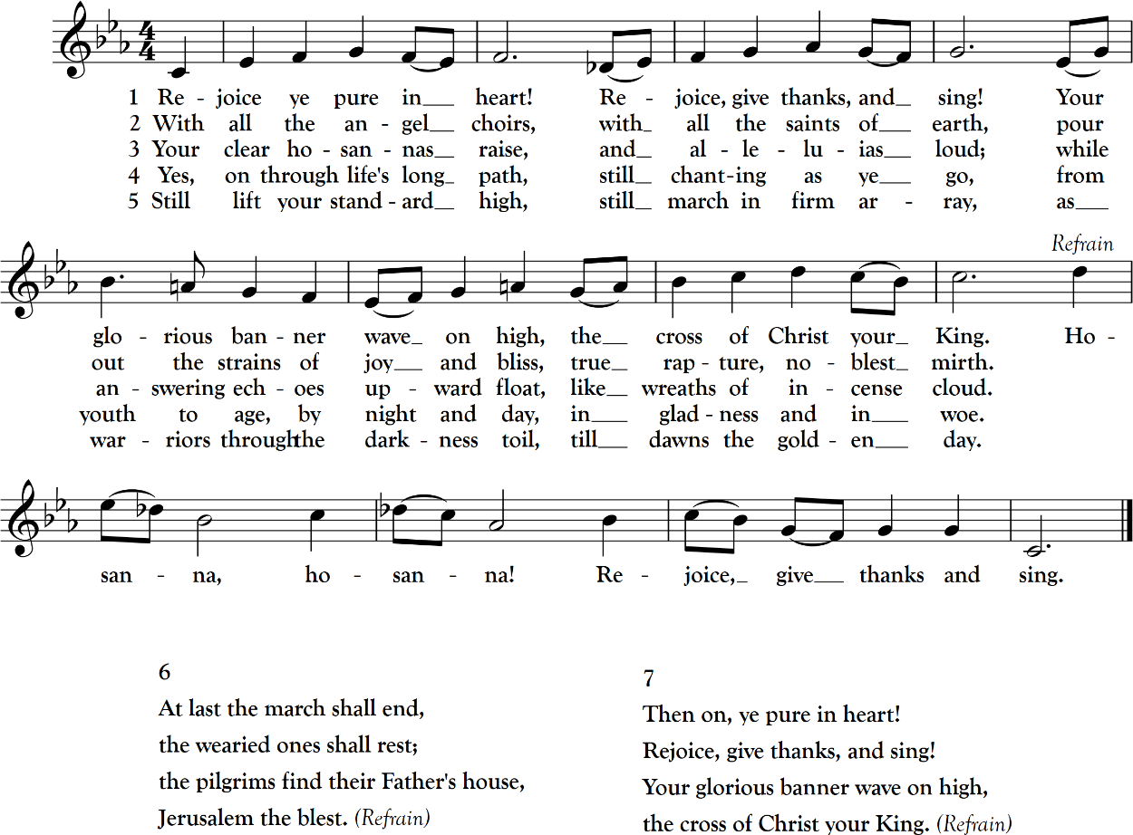

Rejoice, ye pure in heart, #557 from The Hymnal 1982 — Words: Edward Hayes Plumptre (1821-1891).
Music: Vineyard Haven, Richard Wayne Dirksen (1921-2003).

Magnificat Aedes Christi [I] Sebastian Forbes (b. 1941)

M
y soul doth magnify the Lord,
and my spirit hath rejoiced in God my Savior.
For he hath regarded the lowliness of his handmaiden.
For behold from henceforth all generations shall call me blessed.
For he that is mighty hath magnified me, and holy is his Name.
And his mercy is on them that fear him throughout all generations.
He hath showed strength with his arm;
he hath scattered the proud in the imagination of their hearts.
He hath put down the mighty from their seat, and hath exalted the humble and meek.
He hath filled the hungry with good things, and the rich he hath sent empty away.
He remembering his mercy hath holpen his servant Israel,
as he promised to our forefathers, Abraham and his seed for ever.
Glory be to the Father, and to the Son, and to the Holy Ghost;
as it was in the beginning, is now, and ever shall be, world without end. Amen.

The People sit.

Second Lesson 1 Thessalonians 5:12-24
A
nd we beseech you, brethren, to know them which labour among you,
and are over you in the Lord, and admonish you;
And to esteem them very highly in love for their work’s sake. And be at peace among yourselves.
Now we exhort you, brethren, warn them that are unruly,
comfort the feebleminded, support the weak, be patient toward all men.
See that none render evil for evil unto any man; but ever follow that which is good,
both among yourselves, and to all men.
Rejoice evermore. Pray without ceasing.
In every thing give thanks: for this is the will of God in Christ Jesus concerning you.
Quench not the Spirit. Despise not prophesyings.
Prove all things; hold fast that which is good.
Abstain from all appearance of evil.
And the very God of peace sanctify you wholly; and I pray God your whole spirit
and soul and body be preserved blameless unto the coming of our Lord Jesus Christ.
Faithful is he that calleth you, who also will do it.

So ends the Second Lesson.

The People stand for the Nunc dimittis and the Creed.

Nunc dimittis Aedes Christi [I] Sebastian Forbes

L
ord, now lettest thou thy servant depart in peace according to thy word.
For mine eyes have seen thy salvation;
Which thou hast prepared before the face of all people;
To be a light to lighten the Gentiles, and to be the glory of thy people Israel.
Glory be to the Father, and to the Son, and to the Holy Ghost;
as it was in the beginning, is now, and ever shall be, world without end. Amen.

The Apostles’ Creed

I
believe in God, the Father almighty,
maker of heaven and earth:
And in Jesus Christ his only Son our Lord:
who was conceived by the Holy Ghost,
born of the Virgin Mary,
suffered under Pontius Pilate,
was crucified, dead, and buried.
He descended into hell.
The third day he rose again from the dead.
He ascended into heaven,
and sitteth on the right hand of God the Father almighty.
From thence he shall come to judge the quick and the dead.
I believe in the Holy Ghost,
the holy Catholick Church, the communion of saints,
the forgiveness of sins, the resurrection of the body,
and the life everlasting. Amen.

The Prayers

Sung by the Choir

. The Lord be with you.
. And with thy spirit.

The People kneel.

Let us pray.

. Lord, have mercy upon us.
Christ, have mercy upon us.
Lord, have mercy upon us.

Our Father who art in heaven,
hallowed be thy name;
thy kingdom come; thy will be done,
on earth as it is in heaven.
Give us this day our daily bread.
And forgive us our trespasses,
as we forgive those who trespass against us.
And lead us not into temptation;
but deliver us from evil. Amen.

. O Lord, shew thy mercy upon us.
. And grant us thy salvation.

. O Lord, save the State.
. And mercifully hear us when we call upon thee.

. Endue thy Ministers with righteousness.
. And make thy chosen people joyful.

. O Lord, save thy people.
. And bless thine inheritance.

. Give peace in our time, O Lord.
. Because there is none other that fighteth for us, but only thou, O God.

. O God, make clean our hearts within us.
. And take not thy Holy Spirit from us.

The Collect of the Day

A
lmighty and gracious Father, we give thee thanks for the fruits of the earth in their season
and for the labors of those who harvest them. Make us, we beseech thee, faithful stewards of thy great bounty, for the provision of our necessities and the relief of all who are in need, to the glory of thy Name; through Jesus Christ our Lord, who liveth and reigneth with thee and the Holy Spirit, one God, now and for ever. Amen.

The Collect for Peace

O
god, from whom all holy desires, all good counsels, and all just works do proceed:
Give unto thy servants that peace which the world cannot give,
that both our hearts may be set to obey thy commandments, and also that by thee,
we, being defended from the fear of our enemies, may pass our time in rest and quietness;
through the merits of Jesus Christ our Savior. Amen.

The Collect for Aid against all Perils

L
ighten our darkness, we beseech thee, O Lord;
and by thy great mercy defend us from all perils and dangers of this night;
for the love of thy only Son, our Savior Jesus Christ. Amen.

The People sit.

Anthem at the Offertory Sung by the Choir Ned Rorem
(1923-2022)

O
god, my heart is ready, my heart is ready :
I will sing, and give praise with the best member that I have.
Awake, thou lute and harp : I myself will awake right early.
I will give thanks unto thee, O Lord, among the peoples :
I will sing praises unto thee, among the nations.
For thy mercy is greater than the heavens : and thy truth reacheth unto the clouds.
Set up thyself, O God, above the heavens : and thy glory above all the earth.
That thy beloved may be delivered : let thy right hand save them, and hear thou me.
God hath spoken in his holiness : I will rejoice.
Hast not thou forsaken us, O God : and wilt not thou, O God, go forth with our hosts?
O help us against the enemy : for vain is the help of man.
Through God we shall do great acts : and it is he that shall tread down our enemies.

Psalm 108:1-7, 11-13



Please scan this QR code if you wish to give online from your mobile device or text Give to 855-938-2085.

Prayers and Intercessions

Let us give thanks to God our Father for all his gifts so freely bestowed upon us.
For the beauty and wonder of your creation, in earth and sky and sea.
All: We thank thee, O Lord.

For all that is gracious in the lives of men and women, revealing the image of Christ,
All: We thank thee, O Lord.
For our daily food and drink, our homes and families, and our friends,
All: We thank thee, O Lord.
For minds to think, and hearts to love, and hands to serve,
All: We thank thee, O Lord.
For health and strength to work, and leisure to rest and play,
All: We thank thee, O Lord.
For the brave and courageous, who are patient in suffering and faithful in adversity,
All: We thank thee, O Lord.
For all valiant seekers after truth, liberty, and justice,
All: We thank thee, O Lord.
For the communion of saints, in all times and places; for the Blessed Virgin Mary, Mother of God, and Saint Thomas our patron,
All: We thank thee, O Lord.
Above all, we give thee thanks for the great mercies and promises given to us in
Christ Jesus our Lord;
All: To him be praise and glory, with thee, O Father, and the Holy Spirit, now and
for ever. Amen.

Most gracious God, by whose knowledge the depths are broken up and the clouds drop down the dew: We yield thee hearty thanks and praise for the return of seed time and harvest, for the increase of the ground and the gathering in of its fruits, and for all other blessings of thy merciful providence bestowed upon this nation and people. And, we beseech thee, give us a just sense of these great mercies, such as may appear in our lives by a humble, holy, and obedient walking before thee all our days; through Jesus Christ our Lord, to whom, with thee and the Holy Ghost be all glory and honor, world without end.
All: Amen.

Hymn materna
O beautiful for spacious skies, #719 from The Hymnal 1982 — Words: Katherine Lee Bates (1859-1929).
Music: Materna, Samuel Augustus Ward (1848-1903).

The Blessing

The Officiant says

M
ay God the Holy Trinity make you strong in faith and love, defend you on every side,
and guide you in truth and peace; and the blessing of God Almighty, the Father,
the Son, and the Holy Spirit, be among you, and remain with you always. Amen.

Voluntary Psalm 33:3 from Psalm Preludes Buck McDaniel
"Sing unto the Lord a new song; sing praises lustily unto him with a good courage" (b. 1994)

